Zoom Telehealth User Instructions for Tablet/Smartphone

Step 1: You will need a device (smartphone, tablet, laptop, PC, etc) with a camera, speakers, and microphone.
NOTE: Please leave yourself plenty of time to get the app downloaded before your scheduled meeting time.

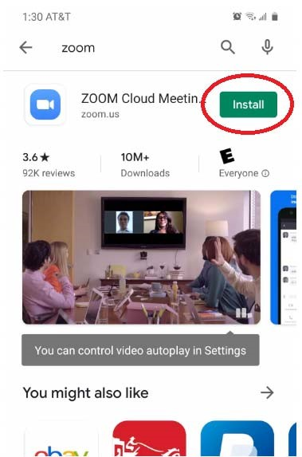
Step 2:
Smartphone/Tablet: Go to your device’s app store, search for and download the Zoom Cloud Meetings app.

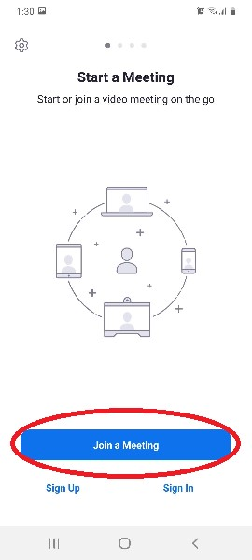

Step 3:
Smartphone/Tablet: Open the app and click on Join a Meeting.

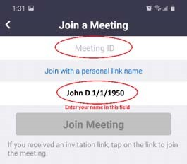
Step 4: Enter the meeting
ID number provided by NorthCare and your name and click “Join.”
NOTE: Please enter your name in this format if possible to better identify you and start your appointment on time:
“First Name” “Last Initial” “Date of Birth”
Example: John D 1‐1‐1950
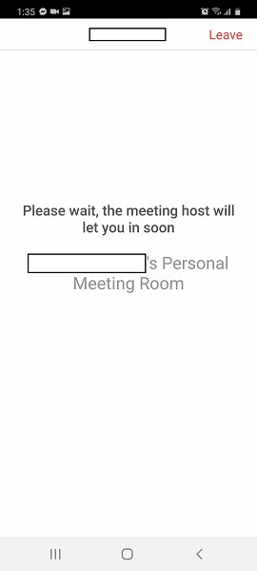

Step 5: Wait for your provider to start the meeting. If you get any pop‐ups asking to allow Zoom to use your device’s camera or microphone, please accept them.

Step 6: When your appointment starts, please click at the bottom to “Join Audio” and “Call via Device
Audio” and then click on Start Video.

